Name: ____________________________________ Date: ___________ Period: _______

Amelia is making a drawing to determine the length of a fence needed to go around her garden. Using the given coordinates, draw an outline of her garden (polygon ABCDEF) and determine the total length of fencing needed. Show all work neatly and completely to justify your answer.

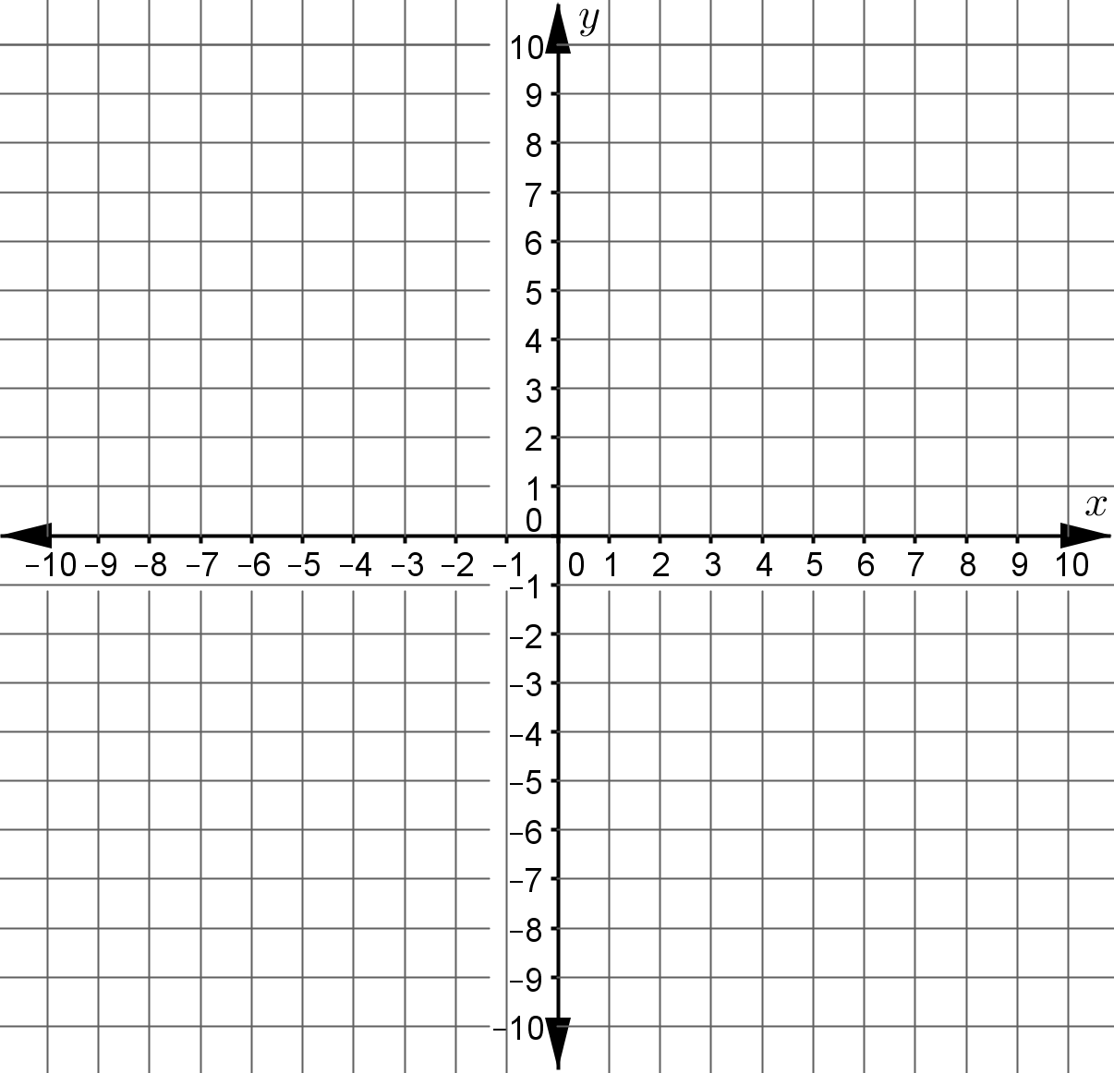
A (6, 3)
B (6, -4)
C (-10, -4)
D (-10, 7)
E (-5, 7)
F (-5, 3)

