Name: ____________________________________ Date: ___________ Period: _______

The coordinates of the vertices of polgyon EFGH are:

E (-5.5, 4) F (-2, 8.25) G (2.5, 4) H (-2, -7.75)

- Graph the polygon and label the vertices.

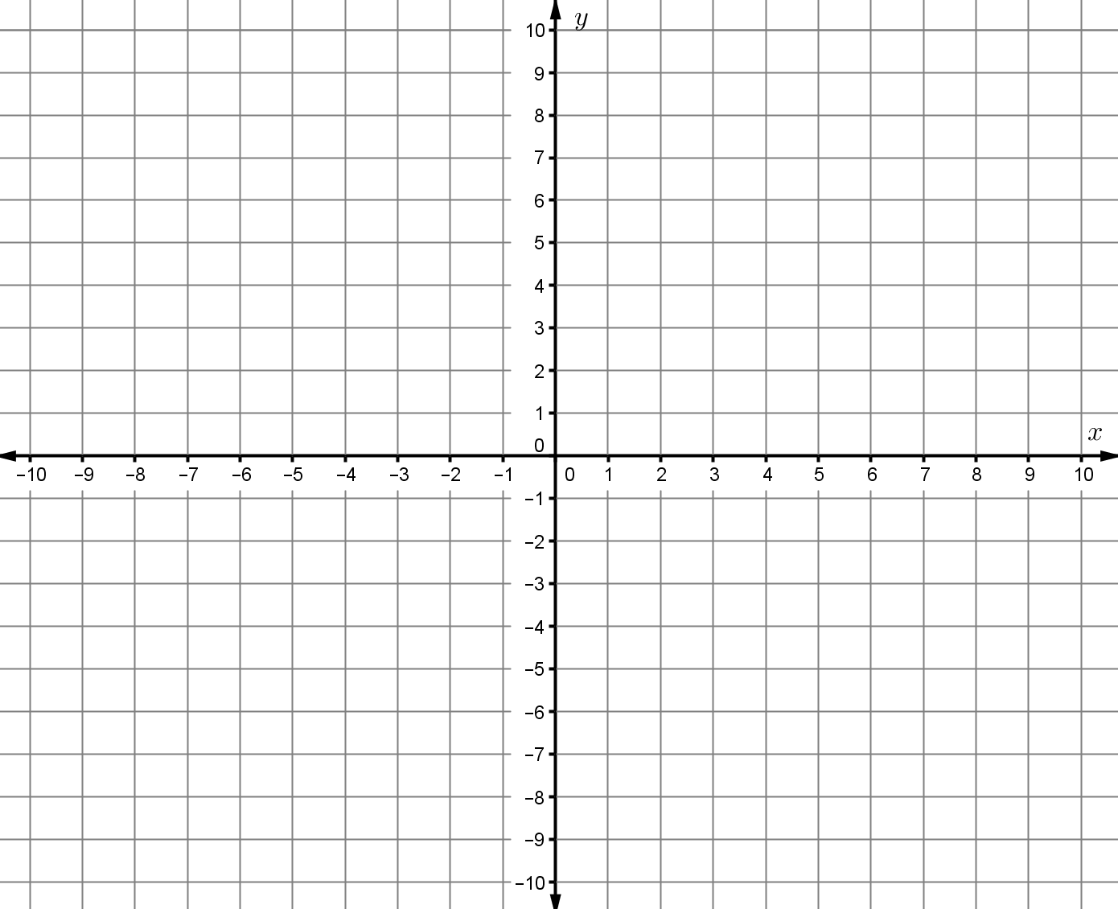

- Find the length of each diagonal ($\overline{EG}$ and $\overline{FH}$). Show your work clearly or explain how you found the lengths.

