Name _______________________________ Date___________

When landing a plane, it is important for pilots to know which way the wind is blowing. In the past, some airfields without control towers used large tetrahedrons (triangular pyramids) that would rotate in the wind to show the direction the pilot should land.

An airstrip’s tetrahedron is made by covering the exterior of its steel frame in sheet metal. Use the net below to calculate the area of sheet metal needed. All measurements are in feet.
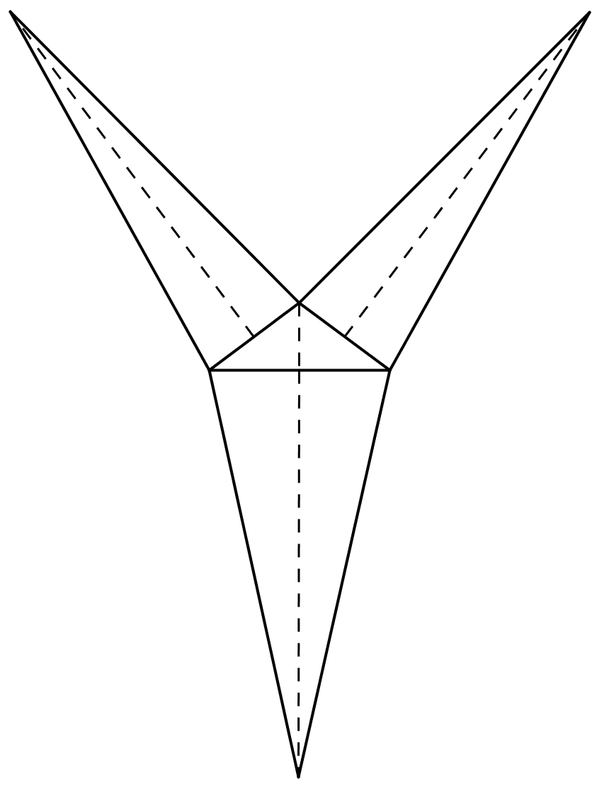
18 ft.
8 ft.
18 ft.
5 ft.
5 ft.
3 ft.
18 ft.

